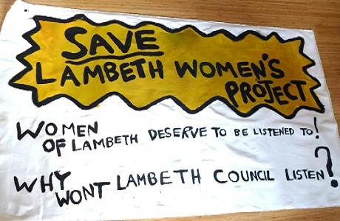
JOIN US !!

PROTEST AGAINST THE EVICTION OF

LAMBETH WOMAN'S PROJECT

WEDNESDAY 19TH JUNE 2012

OUTSIDE LAMBETH TOWN HALL
(bring a pot to bang)

Followed by

SOLSTICE DISCO & 'BBQ'
@ LWP
166A Stockwell Road SW9 9TQ

contact: LWP 0207326 4447
lambethwomensproject@gmail.com
https://www.facebook.com/events/370541929673809/

