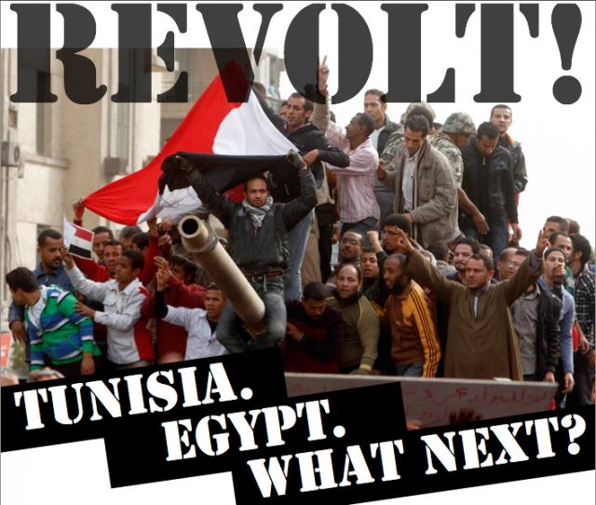
Revolt! Tunisia. Egypt. What Next?
Following the overthrow of Tunisia’s brutal dictator, workers and the oppressed all over North Africa and the Middle East are engaging in mass struggle. People are fighting for food and democracy.
The movement in Egypt could completely change the balance of power in the Arab world. Domination of the region by imperial powers now hangs in the balance.
The “poverty riots” are combined with an immense mobilization for democracy. They are creating the conditions for the opening processes of social and democratic revolutions.
Join a discussion about where the movement is headed and what we can do in the U.S. to show solidarity.
Where: San Diego City College- room
Date and Time: Thursday February 17th 11am
Organized by: City College Socialist Club and Education For All Coalition

