Garden Brief Friday 9 Oct. 09
Physical dimensions and lay-out of existing beds:
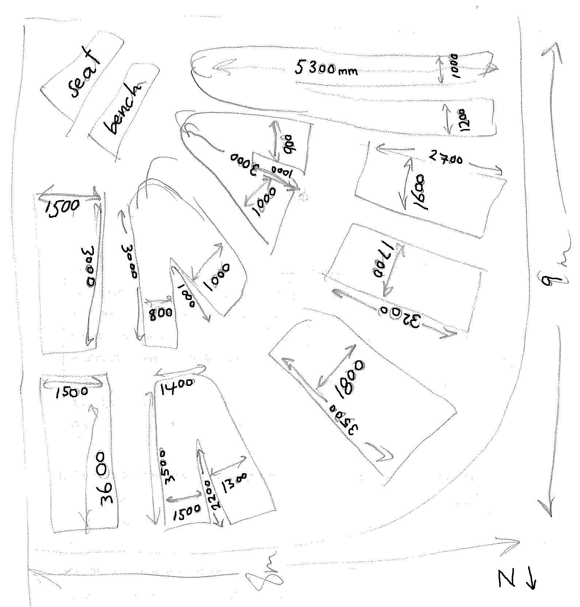
The east and south side of the garden is lined by trees/ shrubs. To the west is a row of pine trees which shade most of the garden except for the NE corner by 3.30pm DST.

Aims:
- Productive food source (rotational crop design)
- supply herbs and salads to Wholefoods (on campus) student-run restaurant
- Education resource for students/ staff/ wider community
- Aesthetic and functional design that is as low-maintenance as possible
- Addition of pond for frogs/watercress, for resident visiting ducks – we wish to encourage local wildlife to the garden/ promote biodiversity as much as possible.
- Berries
Logistics:
- Sleeper-defined beds
- Herbs and seeding station currently present on balcony outside Wholefoods
- Greenhouse location?
- Water tank location?
- Fence?
- composting system

What we wish to keep, but may need moving:

- Peach trees (we have rogue seedlings)
- curry bush
- Geranium
- Mint
- Lemon balm
- Lemon verbena
- Banana (we have one healthy tree)
- Parsley
- Coriander
- Lemon tree (in a pot)
- Rosemary

Who’s involved: Garden crew (a handful of regulars), Monash Environmental Group members,
Skills: general maintenance

