Executive Summary for Bugesera Project.
  - Bugesera Project 2013
This executive summary details the project timescales and costing for proposed Bugesera project.

History

Rwanda is an amazing country, described as ‘a land of a thousand hills’. When speaking to people about Rwanda they always recall the genocide of 1994 where an estimated 1 million people were killed in 100 days. They never talk about the way in which Rwanda has rebuilt itself in the last 18 years.
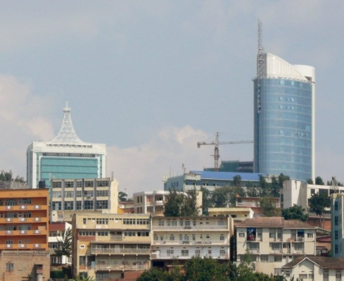

Rwandans are amazing people who do not want to survive on charity, they are very proud and strive to work to support their families. This ethos is the aim of ISHYA, to build sustainable businesses which will fund community projects and a boarding school for orphans.

During my second trip to Rwanda I had the privilege to meet some amazing women. These women have lived through experiences which none of us can imagine. During the genocide their husbands were murdered along with multiple family members, they were subjected to rape and left to die.

My dear friend Solange heard about the women in the Bugesera district and made many visits to these women. She offered them someone to talk to, someone who was interested in their lives and was concerned about them. After building a rapport with these women Solange spoke with them about their future. They wanted, not to rely on charity but to build a business which would support their families. With this in mind, Solange helped them by setting up a pineapple plantation, sewing business and a handicraft business.

This led Solange to the vision of ISHYA, an organisation which supports the local community through providing education and running sustainable businesses. After long discussions with Solange we were honoured when she spoke of us working together and setting up a UK Branch of ISHYA to achieve her vision.

The population of Bugesera has lived through the most horrific experiences humankind can imagine and they are trying to rebuild their lives. The Bugesera district was one of the worst hit areas during the 1994 genocide, approximately 60,000 Tutsis and moderate Hutus were killed in Bugesera. This atrocity is reflected in the Nyamata Church Genocide Memorial which holds 40,000 bodies and the Ntarama Genocide Memorial site.

The aim of ISHYA is to build sustainable local businesses and conference facilities which will fund the running of a local school with boarding accommodation and build the Bugesera district into a district which has a positive future, supporting the local community through sustainable, successful businesses.
Ishya Organisation

Who we are

Name of Business – ISHYA Organisation

Business Address –

Rwandan Branch – PO Box 6844
Kigali
Rwanda

UK Branch -
106 North Parade
Sleaford
Lincolnshire
NG34 8AW
England

Telephone Number – Rwandan Branch - +250788406935
UK Branch - +44 (0)7969685898 +44(0)1529 572020

Date business commenced – 07/08/2012

Legal Status – non-profit

Principle activities –

Our principle activities will be based on one site housing 10 businesses which will support a boarding school for 1,000 orphans and 620 school places for local children. ISHYA’s focus is building sustainable businesses and working to offer community support in the Bugesera district of Rwanda. These businesses will not only provide sustainable futures but the profits will fund the running of the school which will offer high quality education with business and finance training to all students.

Our Business objectives

Short term – To purchase 3 hectares of land required to build the boarding school and the central hub and to continue running and expanding the 5 businesses already in place.

Medium term – Our medium term objectives are to build ISHYA central hub and boarding school and expand to 11 associated businesses.

Long term – Our long term objectives are to run a successful school for 1,6500 children and have a number of sustainable businesses associated with ISHYA. We also want to promote community cohesion through the community centre and facilities which will be made available on site.

Our Ladies
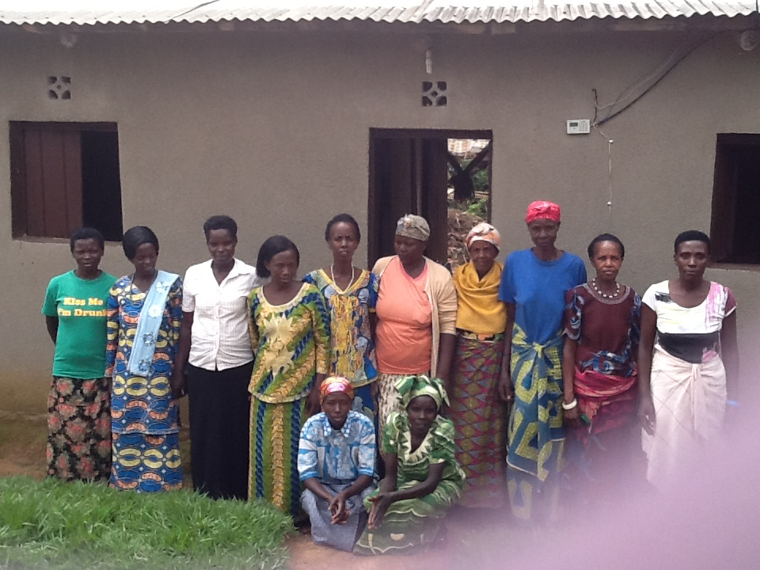

Proposed Businesses

Diag. 1

Land Requirements

We need approximately 3 hectares of land to build the centre on in the Bugesera district. We are currently in the process of examining a 3 hectare area of land at cost of 25,000,000 Rwf, £25,000. We have spoken with the Mayor of Bugesera and the district leader of Ntarama who are supportive of our aims and how we intend to promote the area as a place to conduct business.

Current Projects

4 of the proposed projects in Diag 1 are already underway; these are based on temporary sites until we are able to secure funds to build the main complex which will house all the businesses, school and community facilities.

Mothering Our Future School Kigali

Mothering our Future school in Kigali provides private education to local children with an emphasis on family responsibilities, high quality education, life and business awareness and educating children in becoming responsible citizens. The school fees charged are below current market rates, we have done this to make quality education available to low income families, and all profits from the school go to fund ISHYA Bugesera projects. We currently provide education to lower class, middle class and upper class along with day care facilities. This year we have had new registrations for P1 and P2 and are required by the district leaders to convert the old church building on our current site to separate nursery from primary.

Our aim is to expand Mothering to provide education from P1 to P6. This expansion is currently being planned and we have identified new premises which would allow us to expand and offer education up to P6. This would be compliant with the local authority requirements and ensure the school is sustainable, generating a profit margin to fund the Bugesera project. The school will be offering extra-curricular subjects to students in order to encourage entrepreneurship and enabling our students to achieve their full potential. Financial literacy is an important aspect of our curriculum. Children are like sponges and by including financial literacy into the curriculum at an early age we will be ensuring they encompass this throughout their lives. Recent research conducted by the Organisation for Economic Co-operation and Development (OECD) tested whether students were prepared for future challenges, whether they can analyse, reason and communicate effectively, and whether they have the capacity to continue learning throughout their lives. These assessments allowed the OECD to assess if compulsory education had allowed the students to acquire the knowledge and skills essential for full participation in society. The results showed that financial literacy was an essential addition to the curriculum.

In today’s global economy it is important for our children to be financially literate to enable future business, positively contributing to the economy, the country and the world. The school in Bugesera will run on the same model as Mothering.

Ishya Handcrafts

There are currently 16 women making baskets and jewellery. These goods are currently being exported as well as being sold locally. We propose developing a page on the website to promote these goods and expand export globally. This will be done through social media and by approaching retail outlets. In addition to this we are also proposing holding basket-making workshops for tourists which will bring in another revenue stream. We are currently unable to provide this due to the current housing.

Ishya Sewing

There are currently 12 girls working on this project and they are sharing 6 ordinary foot pedal sewing machines. I am currently in discussion with a company called Dreamyz, which is a Canadian company, to supply of all their products. Additionally we would look to expand their market though social media and exporting to other supply chains, promoting our services to local schools and entering the global market. The boarding school would also purchase uniforms from here along with other Rwandan schools.

Ishya Agriculture

A plot of land has been cultivated and is currently growing pineapples. There are 11 women working on this. We have identified new land at a cost of £300 and the current product could be moved in the rainy season. The new land would benefit from an irrigation system and a small juicing plant to increase turn-over and facilitate expansion. We have also identified a market for pilli pilli chillis and are currently investigating this further. We have had discussions with the district leader of Ntarama who is identifying appropriate land for us.

Proposed Projects

Ishya Bakery

A bakery business is being proposed at the community hub site to provide local employment and supply fresh goods to the school, café, restaurants, local schools, supermarkets, hotels and surrounding community. This would provide initial employment for 10 people. The bakery can initially be housed in temporary housing in the new premises for the hand-craft business and then moved to the purpose-built accommodation after completion of the main build.

Boarding school

We propose building a boarding school on site. The target number of students is 1,620 but we propose doing this is stages to allow for structured growth and sustainability.

The initial intake would be 1 class per year group with gradual expansion to minimise problems and allow the children to settle into their routines and new environment. We aim to cater for P1 through to S6.

Community hub

The community hub will provide business advice, health advice, parenting classes, crèche, trauma counselling, library, access to computers and internet for the local community. There would also be the facility for community gatherings at the café and grounds.

Ishya Corporate Hire

Ishya corporate hire will provide conference/seminar/presentation venues of international quality for corporate businesses to hire. We would also provide IT suits to hire for local NGOs and firms. Bugesera is a fast growing area and with the new international airport being located near us we feel that the facilities of a business and corporate venue will be a fantastic venture.

Ishya Livestock

The livestock business will provide goats, chickens and cows for local widows. This will be expanded through animal husbandry and the offspring of the original animals will be given to widows. The produce from these will be sold to generate income.

Ishya Café

A café is being proposed at the community hub site to provide local employment, a community meeting point and also to attract tours visiting the neighbouring memorial sites. The café would be promoted to tour companies and would aim to provide a relaxing and friendly environment where people could also see local goods being made with the opportunity to purchase items. It would also showcase business in Rwanda and reinforce to visitors how Rwanda has rebuilt as a business hub after the genocide. In the evening the café would provide a local community area.

Ishya Bio-fuel

The bio-fuel business would have a demonstration unit at the front of the community hub where people could see the installed system. There would be the opportunity for purchasing a bio-fuel system and we would look to expand to the surrounding areas and approach government for their support. The system would be installed to potential customers by a crew of trained local people.

Current situation

The property we are currently renting in Ntarama, Bugesera is no longer viable as the landlord requires the property back. We have identified a new location in Ntarama which is £100 per month rent. This premise is sufficient to temporarily locate the handicrafts, sewing workshop and start the bakery until the ISHYA complex is built. We would be able to run the workshops for tourists here which would increase the income and awareness.

To complete these projects we require funds to purchase and install the equipment. After an initial 6 month period the businesses would aim to be self-sufficient and starting to build profits which will provide funding for the school and go towards the capital required for the main build.

Phase One

The funds we require to set phase one of the project up and running for the first 6 months are: - (after the initial 6 months the business would be self-sufficient).
Total equipment for set up of Bakery - £7,595.32
Total for expansion at Mothering School in Kigali to provide education up to primary 6 - £27,784
Total equipment for set up/expansion of sewing - £6,130
Total running costs for 6 months (including rent, taxes, wages, rates, air fares for trainers, staff) -£27,680

Grand total for phase one - £69,189.32

Phase Two

Phase two would be purchasing the land starting the build of the boarding school and the whole proposed complex.

The amount we require to start phase two is £250,000. This would allow us to purchase the land and commence building the boarding school and associated complex. We would be looking for companies to sponsor this stage of the project.

We are currently in talks with a company who is proposing building the school in Ntarama with their new building system as part of their CSR policy.

Complete project

The total amount required for the whole ISHYA complex build and running is £950,000. Once the complex is completed and been running for 18 months, financial projections show that the associated businesses should financially support the community projects and fund the boarding school.

